**Project Design Phase**

**Solution Architecture**

|  |  |
| --- | --- |
| Date | 15 February 2025 |
| Team ID | LTVIP2025TMID30127 |
| Project Name | Edututor -ai |
| Maximum Marks | 4 Marks |

**Solution Architecture:**

**Solution Architecture** is a structured process that connects business problems with practical technology solutions. It involves identifying the most suitable tools, systems, and design patterns to address business needs effectively.

The goals of Solution Architecture in the context of **EduTutor AI** (or any tech project) are to:

* **Find the best technology stack** to address existing educational and operational challenges.
* **Describe the structure, behaviour, and technical design** of the platform to all stakeholders including developers, educators, and institutions.
* **Define core features**, establish development phases (e.g., MVP, Beta, Full Release), and outline **functional and non-functional requirements**.
* **Provide technical specifications and architectural standards** that ensure the solution is robust, scalable, and aligned with business goals.

**Solution Architecture Diagram:**

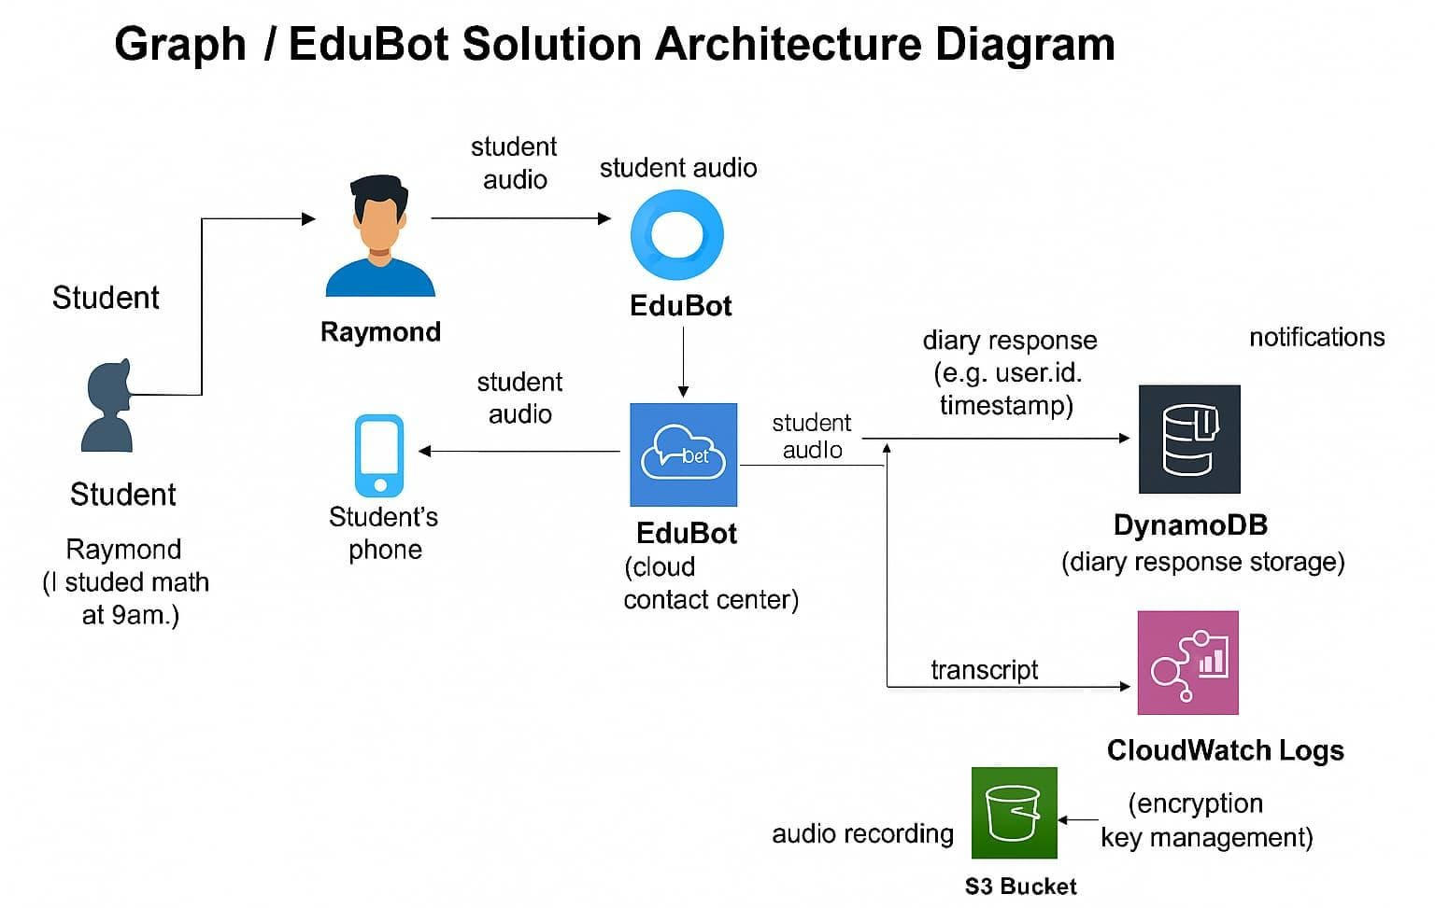

*Figure 1: Architecture and data flow of the voice patient diary sample application*